1. Consider a dipole antenna with a/λ = 0.006 at 600 MHz.
   1. Find its resonant length and resonant resistance using the plots. Plot R and X over 470-750 MHz using Tai’s formula.

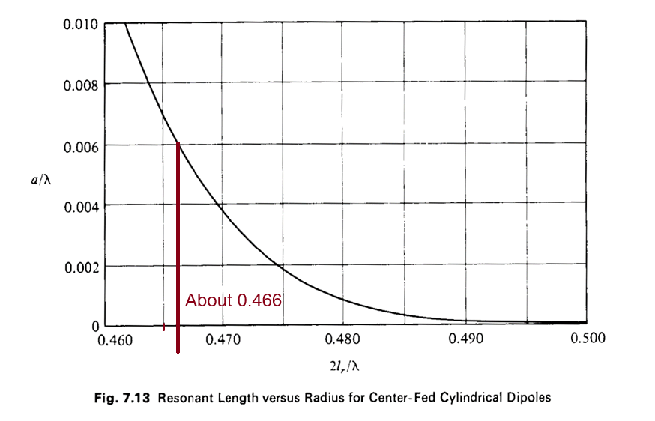

$$λ_{0}=\frac{c_{0}}{f_{0}}=\frac{299792458 m/s}{600 MHz}≈50 cm$$

$$\frac{2l_{r}}{λ}≈0.466→l_{r}≈11.64 cm$$

Dipole Length = $23.28 cm$

Figure 1 Code

syms f

lambda = 3e8/f;

length = 0.233 \* 3e8/600e6;

alpha = 0.006;

k(f) = (2\*pi)/lambda;

R(f) = 122.65 - 204.1\*k(f)\*length + 110\*(k(f)\*length)^2;

X(f) = -1\*( 120\*(log(2\*length/alpha - 1) \* cot(k(f)\*length)) - 162.5 + 140\*k(f)\*length - 40\*(k(f)\*length)^2 );

f1 = linspace(470e6, 750e6, 20);

F = figure;

F.Position = [0,0,800,600];

centerfig(F);

yyaxis left

plot(f1./1e6, R(f1), "DisplayName", "Ohmic Resistance");

ylabel("R(f) \Omega", "FontSize", 14);

hold on;

yyaxis right

ylabel("X(f) \Omega", "FontSize", 14)

plot(f1./1e6, X(f1), "DisplayName", "Reactance");

title("Plot of R(f) and X(f) from 470MHz to 750MHz", "FontSize", 18);

xlabel("Frequency (MHz)", "FontSize", 14);

grid on;

legend();

Figure 2 Code

F2 = figure;

F2.Position = [0,0,800,600];

centerfig(F2);

plot(f1/1e6, k(f1).\*length);

grid on;

title("kl factor from 470MHz to 750MHz", "FontSize", 18);

ylabel("kl factor");

xlabel("Frequency (MHz)");

text(536, 1.8, {"Frequency range is mostly within the", "function domain of 1.3 <= kl <= 1.7"}, "FontSize", 15);

yline(1.3, '--', 'color', 'red', 'LineWidth', 2);

yline(1.7, '--', 'color', 'red', 'LineWidth', 2);

xline(532.8, '--', 'color', '#D95319', 'LineWidth', 2);

xline(696.73, '--', 'color', '#D95319', 'LineWidth', 2);

pca = gca;

pca.GridAlpha = 0.35;

